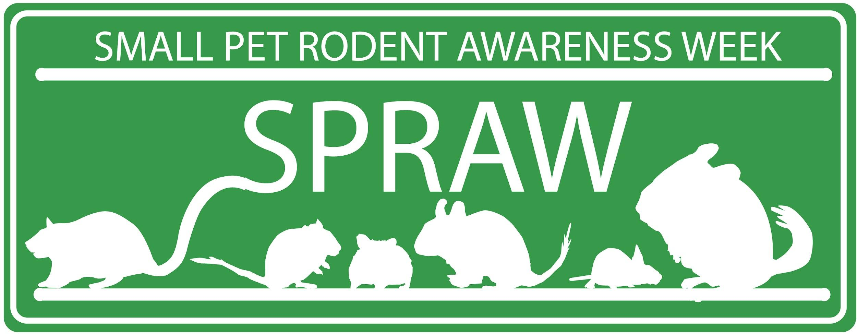
MP Letter Template - set minimum standards for Rodent housing
Instructions
The template letters in this pack are intended to be shared with your MP, MSP or similar Elected Member, to enlist their support in changes to legislation and policy
When using these templates, we encourage you to:
- Change and personalise the letter to your circumstances. We want the letter to best represent your perspective on the campaign.
- Please try to maintain a similar tone to the message – we need to encourage support and collaborative action as opposed to demand change instantly.
- Do be concise and factual.
- Do share your interest, e.g. if you are a pet owner, volunteer etc.
- Do share experiences that bring the issue to life.

Fund out who your representatives are

England https://members.parliament.uk/FindYourMP

Scotland https://beta.parliament.scot/msps/current-and-previous-msps

Wales https://senedd.wales/find-a-member-of-the-senedd/

Northern Ireland http://www.niassembly.gov.uk/your-mlas

Legislation on Equipment Sold As Suitable for Rodents
Dear [add MP name here],
I am writing to you about my concerns relating to equipment sold within the pet industry as “suitable for rodents” within the UK.
Research conducted and supported by animal welfare experts such as the PDSA and RSPCA demonstrates that pet rodents need to live in large enclosures to meet their welfare needs, however guidance is conflicting and many pet stores continue to sell hutches and cages that are often much smaller than recommended.
I am concerned that the availability of suitable equipment, combined with inconsistent guidance and low levels of rodent welfare education at point of sale, leads to animals suffering a life of misery and pain in cramped conditions. This ultimately results in strain on animal welfare organisations who are often left to pick up the pieces.
Can I ask you for your support? Please propose and be an advocate for legislation on the size and suitability of all equipment sold as suitable for rodents sold as companion animals in the UK, whilst also introducing policy and guidance to ensure rodent owners are better informed of welfare needs through education at the point of sale.

Yours sincerely,
[Your name]
[Your address and postcode]

